

Melkbosstrand High School
Grade 10 | Computer Applications Technology |  | Term 2  28 May 2026
Time: 2.5 hours | Task 3:  Practical |  | Marks: 100
Examiner: F. Pretorius |  | Moderator: R. Rabe

INSTRUCTIONS AND INFORMATION
- During the examination, normal rules regarding leaving the examination room apply.

- The data files can be found in the Exam Data folder on the network or a local computer. If you are working on the network, you must follow the instructions provided by the invigilator.

- A copy of the master files will be available from the invigilator. Should there be any problems with a file, you may request another copy from the invigilator.

- Answer ALL the questions.

- Ensure that you save each document using the file name given in the question paper. Save your work at regular intervals as a precaution against possible power failures.

- Read through each question before answering or solving the problem. Do NOT do more than is required by the question.

- During the examination you may consult the offline help functions of the programs that you are using. You may NOT use any other resource material.

- Unless instructed otherwise, use formulae and/or functions for ALL calculations in questions involving spreadsheets. Use absolute cell references only where necessary to ensure that formulae are correct when you copy them to other cells in a spreadsheet.

- If data is derived from a previous question that you could not answer, you should still proceed with the questions that follow.

- In all questions involving word processing, the language should be set to English (South Africa). The paper size is assumed to be A4 Portrait, unless instructed otherwise.

- Ensure that the regional settings are set to South Africa and date and time settings, number settings and currency settings are set correctly.

- The examination folder that you receive with this question paper will contains the files listed below. Ensure that you have all the files before you begin this examination.

- 1Friends.png | Image
- 1Uber Service.docx | Word processing file
- 2Hailing.png | Word processing file
- 2Uber Users.docx | Image
- 3Uber Ride Bookings.xlsx | Spreadsheet
- 4Uber TripsBook.xlsx | Spreadsheet
- 4Uber.png | Image


SCENARIO: The world of Uber rides

An Uber ride may start with directions on a screen, but it often ends with stories shared, laughter exchanged, and strangers leaving as friends.

QUESTION 1: WORD-PROCESSING
Open the 1Uber Service word-processing document.
1.1 | Apply the following edits to the document:
 | 1.1.1 | Change the document size to A4. | (1)
 | 1.1.2 | Set the document margins at 2 cm Top and Bottom, and 3 cm on both sides. | (2)
 | 1.1.3 | Insert a single line page border to the document. | (1)
1.2 | Locate the paragraph above the image that starts with ‘The idea…’ and ends with ‘…electronically and edit it as follow:
 | 1.2.1 | Use the formatting marks to remove all unnecessary spaces between words. | (1)
 | 1.2.2 | Apply the registered symbol ® on the word ‘Uber’ in the paragraph. | (1)
 | 1.2.3 | Insert a comment on the word ‘hail’ with the wording: ‘Hail means calling out for or signalling somebody to come to you.’. | (2)
1.3 | Locate the first paragraph under the heading ‘How the Uber app works’ and apply formatting to the paragraph to resemble the screenshot below:  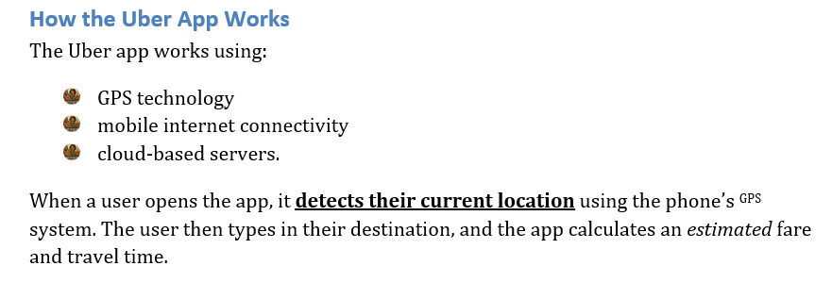  NOTE:  - Use the image 1Friends.png as the bullet. |  | (7)

1.4 | The table under the heading ‘The Impact of Technology on Transportation’ compares certain aspects of Uber transport to traditional taxi transport. Modify the table as follows:
 | 1.4.1 | Change the text direction of the word ‘Uber’ (middle second row) to display upwards in the middle of the cell. | (2)
 | 1.4.2 | Specify the row height from row 3 onwards, to exactly 0.5 cm. | (2)
 | 1.4.3 | Delete the row that indicates the ‘Driver Rating’. | (1)
 | 1.4.4 | Apply a red double-line outside border to the table and set the border thickness to 1½ pt. | (4)
1.5 | Use the Find feature to determine how many times the word ‘taxi’ appears in the document.  Set the number as the author of the Document. |  | (3)
1.6 | Apply the Intense Quote style to the first paragraph under the heading ‘Social and Economic Impact’ beginning with “Uber has both...”.   |  | (2)
1.7 | Apply numbering to all headings formatted with the Heading 2 style so that they display in the required format below: |  | (2)
Save and close 1Uber Service.docx.
 |  |  | [31]

QUESTION 2: WORD-PROCESSING
Open the 2Uber Users word-processing document.
2.1 | Insert a cover page as follows:
 | 2.1.1 | Use the Integral template for your design. | (1)
 | 2.1.2 | Type the following text as the Document Title: “Analysis of the Types of People Who Use Uber”. | (2)
 | 2.1.3 | Type your name and surname in the author control box. | (2)
 | 2.1.4 | Replace the image on the cover page with the image 2Hailing.png which can be found in the examination data folder. | (2)
 | 2.1.5 | Delete the other content control boxes. | (1)
2.2 | Find the word ‘drivers’ and replace each instance (case does not matter) with the same word, double underlined in red. |  | (3)
2.3 | Add the word ‘Ubber’ to the dictionary so that in future it will automatically be corrected to the word ‘Uber’. |  | (1)
2.4 | Insert a text box under the heading ‘9. Road-Related Dangers’ and move the text of the second paragraph into the text box to display as below:  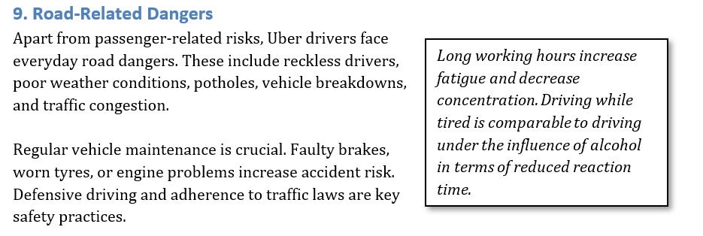  - Apply the Quote style to the text.  - Apply a shadow effect to the text box as shown. |  | (5)
Save and close 2Uber Users.docx.
 |  |  | [17]

QUESTION 3: SPREADSHEETS
_{NOTE:}
- Use formulae and/or functions for ALL calculations in the spreadsheet.
- Use absolute cell references ONLY where it is required by the question to ensure that formulae are correct when you copy it to other cells in the spreadsheet.
Open the 3Uber Ride Bookings spreadsheet.
3.1 | Work in the Sheet 1 sheet.
 | 3.1.1 | Rename the sheet to ‘Categories’. | (1)
 | 3.1.2 | Change the tab colour of the sheet to yellow. | (1)
 | 3.1.3 | Sort the sheet according to the following:  - firstly, alphabetically by Purpose  - secondly, by kilometre distance with the longest distance on top. | (4)
Save your changes to the Categories sheet.

Work in the Bookings sheet.
3.2 | Apply the currency format to data in column E. |  | (1)
3.3 | Change the font for row 1 to 16pt. |  | (1)
3.4 | Enter a formula in cell K3 to determine how many minutes longer than an hour the trip for booking CNR002 lasted. |  | (3)
3.5 | Enter a function in cell K4 to determine the duration of the longest trip. Show your answer in hours with two decimal places. |  | (4)
3.6 | What is the total booking value of all the trips? Enter a function in cell K5 to display your answer. |  | (2)
3.7 | Enter a function in cell K7 to display the number of bookings that were completed. |  | (2)
3.8 | The trip for booking CNR007 took an hour longer than initially indicated.  The formula in cell K8 attempts to recalculate the trip duration. Rectify the formula so that the correct answer of 132.1 is shown. |  | (1)
3.9 | The function in cell K9 attempts to add the total number of kilometres for all the trips.  Rectify the function so that the correct answer is shown |  | (1)
3.10 | Insert a formula in cell K10 to calculate the total amount spent in booking value by the following passengers:  - CNR015, CNR026 and CNR014. |  | (4)
3.11 | If 1 euro (€1) is equal to R21.31, enter a formula in cell K11 to calculate the booking value for booking CNR010 in euros (€). |  | (3)
 |  |  | [29]

QUESTION 4: SPREADSHEETS
_{NOTE:}
- Use formulae and/or functions for ALL calculations in the spreadsheet.
- Use absolute cell references ONLY where it is required by the question to ensure that formulae are correct when you copy it to other cells in the spreadsheet.
- Insert formulae and/or functions in such a manner that the correct results will still be obtained even if the existing data changes.
- Should you need to use building blocks, use the allocated space in the spreadsheet.

Open the 4Uber TripsBook spreadsheet.
4.1 | Apply the following formatting to the cell/cell ranges referenced below:
 | 4.1.1 | Apply formatting to column C so that all the details are visible. | (1)
 | 4.1.2 | Rectify the spelling mistake found in cell C27 and highlight the cell in yellow. | (2)
 | 4.1.3 | Apply text formatting and cell shading to row 2, to distinguish it from the data cells. | (3)
4.2 | The cost per kilometre for a trip is provided in cell G1.  Enter a formula in cell I3 to calculate the total amount Customer1 must pay based on the number of kilometres travelled. Ensure that the formula will calculate correctly when copied to the other cells in the column. |  | (4)
4.3 | Insert a function in cell I4 to determine the least number of trips a customer travelled. |  | (2)
4.4 | Enter a function in cell I5 to calculate the difference between the highest and lowest number of active vehicles for all customers. |  | (5)
4.5 | Determine the average kilometres travelled by all customers. Display your answer in cell I6. |  | (2)
4.6 | The function in cell I7 aims to calculate the amount of kms covered in one trip for Customer1. Rectify the formula to show the correct answer of 0.028. |  | (1)
4.7 | Enter a function in cell I8 to calculate the number of customers with active vehicles. |  | (2)
4.8 | Correct the formula in cell I9 to calculate the average number of active vehicles for all customers. |  | (1)
Save and close 4Uber TripsBook.xlsx.
 |  |  | [23]

GRAND TOTAL: 100

